Chapter 3 Requirements Analysis
This chapter defines the requirements for the AI-assisted network management framework developed in this thesis. It outlines the general objectives of the work, clarifies the functional and non-functional requirements derived from the intended use of the system, and presents the three use cases that guide the design, implementation, and evaluation of the prototype.

3.1 General Objectives
The objective of this work is to design and implement an AI-assisted control framework for the Amarisoft 5G Core (5GC) that enables network management through natural language interaction. Conventional management of a 5G core network requires operators to be familiar with vendor-specific configuration syntax and Remote API semantics, which raises the barrier to routine operational tasks such as parameter changes, multi-component reconfiguration, and fault diagnosis. This work investigates whether a locally deployed Large Language Model (LLM) can be integrated into a controller-based architecture to lower this barrier, by interpreting operator requests expressed in natural language and translating them into validated, executable actions on the Amarisoft 5GC.
The Amarisoft 5GC used in this work is accessed through its Remote API and configuration files, and a separate framework, NetSight, is already deployed in the laboratory to provide access to a locally hosted LLM (Gemma, served via Ollama); NetSight is treated as existing infrastructure rather than a contribution of this thesis. Building on this infrastructure, the proposed framework lets an operator submit a request through a chatbot-style interface, which the LLM interprets and turns into a structured response; a controller then validates this response, identifies any missing inputs, and translates it into either a Remote API call or a configuration-file update. The proposed action is presented to the operator for confirmation before execution, after which the controller reports the outcome — optionally summarized by the LLM in natural language. Development proceeds incrementally, beginning with read-only Remote API queries before introducing LLM-generated requests, validation, operator confirmation, and finally write actions that change the network configuration.
This work builds on previous work carried out on the same Amarisoft 5GC platform, which analyzed the feasibility of constructing a Digital Twin Network (DTN) for the system in accordance with ITU-T Recommendations Y.3090 and Y.3091. That work established practical access to the Amarisoft Remote API over WebSocket, validated both monitoring and control operations, and assessed the platform's DTN capability across six evaluation dimensions, concluding that it supports Level 2 capability overall — structured, near real-time data acquisition and reliable bidirectional interaction, but limited autonomous intelligence and modelling maturity. Notably, that analysis identified automated, rule-based or LLM-assisted orchestration as a feasible route toward advancing the Intelligence and Interactive Mapping dimensions beyond what was achieved. The present thesis builds directly on this direction: the controller and LLM-based interpretation layer developed here can be understood as the external orchestration and decision-making component identified as a necessary next step, extending the previously validated Remote API access from manual, scripted control toward natural-language-driven operation.

3.2 Clarifying the Requirements
The requirements for the controller and orchestration layer were derived from discussions with the supervisor and from the operational structure of the Amarisoft 5GC, and were refined into three representative use cases (Section 3.5).
Functional requirements:
- The system shall accept operator requests expressed in natural language through a chatbot-style interface.
- The system shall use an LLM to interpret the request and generate a structured representation of the intended configuration change, diagnostic query, or corrective action.
- The controller shall validate the structured LLM output against the current network configuration and identify any missing or inconsistent inputs before proceeding.
- The controller shall be able to translate a validated request into either a Remote API call or a configuration-file update, as appropriate to the target parameter.
- The system shall present the proposed action to the operator for confirmation prior to execution.
- The controller shall execute confirmed actions on the Amarisoft 5GC and verify that the intended change has taken effect.
- The system shall be able to identify dependencies between multiple configuration entities when a single operator request affects more than one component (e.g., a new network slice and its associated QoS parameters).
- The system shall be able to analyse operator-provided diagnostic information (log files, configuration files, Remote API outputs) to identify likely causes of a network issue and recommend corrective actions.

Non-functional requirements:
- The controller shall reject or flag LLM outputs that do not conform to the expected structured format, rather than forwarding them for execution.
- No configuration change shall be applied to the Amarisoft 5GC without explicit operator confirmation.
- The framework shall be extensible to additional configuration parameters and use cases beyond the three evaluated in this work.
- The system shall rely on a locally deployed LLM, without dependence on external cloud services, consistent with the laboratory's existing NetSight deployment.

3.3 Time frames
Table 1: Milestones
10.05.2015 to 17.05.2015: | Analysis of the requirements
17.05.2015: | Submission of the requirements analysis
10.05.2015 to 10.06.2015: | Literature review and learning the theoretical background
10.05.2015 to 27.07.2015: | Writing up the thesis and the documentation
11.06.2015 to 30.06.2015: | Elaborating of the concept and planning of the prototype
11.06.2015 to 10.08.2015: | Implementation of the prototype
27.07.2015: | Submission of the Thesis draft to supervisor
27.07.2015 to 10.08.2015: | Revise the thesis based on the proposals from the supervisor
10.08.2015: | Submitting the Thesis to the examination office

3.4 Target State / Target Objectives
Upon completion of this work, the target system consists of a controller application running alongside the NetSight-provided LLM access point, interfacing with the Amarisoft 5GC via its Remote API and configuration files. An operator interacts with the system through a chatbot-style interface to issue natural language requests for configuration changes or diagnostic queries.
For a basic configuration request (Use Case 1), the controller identifies the relevant configuration parameters, applies the change, and verifies its execution. For a request spanning multiple configuration entities (Use Case 2), the controller identifies all affected components and applies a consistent set of modifications — for example, configuring a new network slice together with its associated QoS parameters. For a diagnostic request (Use Case 3), the controller supplies the LLM with relevant log and configuration data, presents the LLM's recommended corrective action to the operator, and, upon confirmation, executes it.
In all cases, the operator retains final control, i.e., no action is applied to the Amarisoft 5GC without explicit confirmation, and the controller reports back the outcome of the executed action. Figure 3.1 illustrates this workflow at a high level.
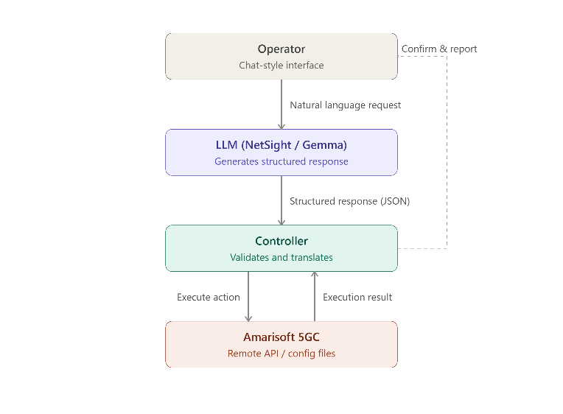
Figure 1: Target system overview

3.5 Use Cases for the Prototype
For a demonstration of the framework's functionality, three representative use cases are implemented and evaluated.
Use Case 1: Basic Configuration Management
This use case addresses isolated, low-risk configuration changes on the Amarisoft 5GC expressed as simple natural language commands. The LLM interprets the operator's request and generates a structured response that enables the controller to identify the required configuration parameters, apply the requested modifications, and verify that they have been successfully executed. The implementation begins with read-only status queries, such as retrieving information on registered UEs, to establish and validate the end-to-end workflow before introducing configuration changes that modify network state.
Representative examples include modifying QoS parameters (e.g., 5QI, GBR, or ARP settings), adjusting network timer values (e.g., T3412 or transaction timeout parameters), and enabling or disabling selected network functions or configuration options.
The primary objective of this use case is to demonstrate reliable translation of simple natural language requests into valid and executable configuration changes.
Use Case 2: Multi-Component Configuration Management
This use case extends the framework to requests that require coordinated changes across multiple configuration entities. Unlike Use Case 1, it evaluates whether the LLM can identify all configuration elements affected by a higher-level request and generate a consistent set of modifications.
Representative examples:
- Configuring connectivity between the AMF and an external network function (e.g., UDM, AUSF, EIR)
- Configuring a new network slice or DNN together with its associated QoS parameters
This use case evaluates the LLM's ability to identify dependencies between configuration entities and to generate modifications that satisfy a higher-level operator request consistently across all affected components.
Use Case 3: Network Diagnosis and Corrective Actions
This use case uses the LLM as a decision-support tool for troubleshooting. The LLM analyzes operator-provided information such as Amarisoft log files, configuration files, or Remote API outputs, to identify likely causes of a network issue and recommend corrective actions. Following operator verification, the controller may execute the approved action.
Representative examples:
- Identifying the cause of failed UE registration attempts
- Detecting inconsistencies between related configuration files or network functions
- Recommending corrective actions such as updating configuration parameters or re-establishing connectivity to external network functions
This use case evaluates the LLM's ability to reason over network diagnostic information and generate reliable, actionable recommendations.

